**Balochistan:**

Hinglaj Mata

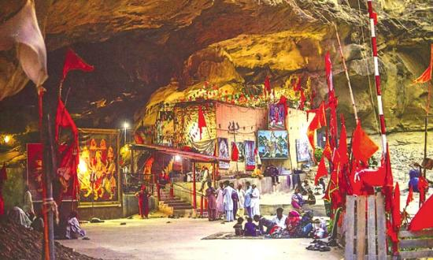

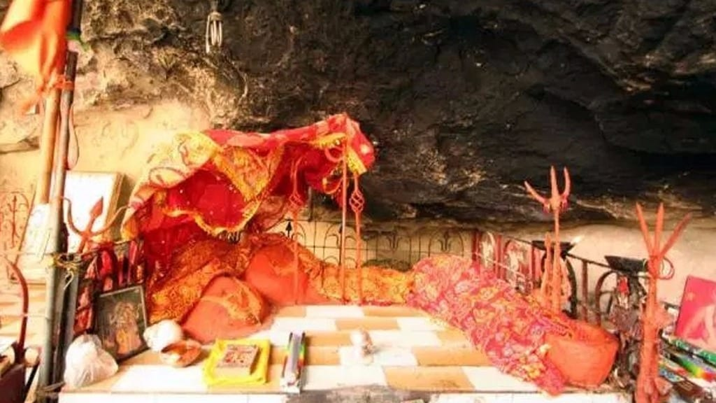

**Hinglaj Mata** also known as **Hinglaj Devi**, **Hingula Devi** and **Nani Mandir**, is a Hindu temple in Hinglaj, a town on the Makran coast in the Lasbela district of Balochistan, Pakistan, and is the middle of the Hingol National Park. It is one of the Shakti Peethas of the Hindu goddess Sati. It is a form of Durga or Devi in a mountain cavern on the banks of the Hingol River. Over the last three decades the place has gained increasing popularity and became a unifying point of reference for Pakistan's many Hindu communities.